Windows XP is an operating system that lets you use different types of applications or software. For example, it allows you to use a word processing application to write a letter, and a spreadsheet application to track your financial information.

Windows XP is a graphical user interface (GUI). It has pictures (graphical) that you use (user) to communicate (interface) with the computer. This type of system is popular because it's logical, fun and easy to use.

This operating system has multitasking capabilities, meaning it can run several applications at the same time. Multitasking allows you to view this lesson on the Internet at the same time that you practice using other applications with Windows XP.

**The Windows XP Desktop**

Like previous versions of Windows, Windows XP uses a **desktop** for the standard interface. Think of the desktop as a workspace where you can access everything you need to operate your computer, such as system components, applications, the Internet, etc.

**The desktop contains:**

* **Start button**: one of the most important tools you will use while working with Windows XP. The Start button allows you to open menus and start applications.
* **Taskbar**: primarily used to switch between open windows and applications. Learn more about using the Taskbar in a later lesson.
* **Icons (or graphical pictures)**: represent applications, files, and other parts of the operating system. By default Windows XP provides you with one desktop icon, the Recycle Bin. Learn more about the Recycle Bin in a later lesson.

http://www.gcflearnfree.org/graphics/lessons/com_lesson_check.gifYour desktop's appearance may vary from the example shown below, especially if you bought a computer with XP preinstalled.

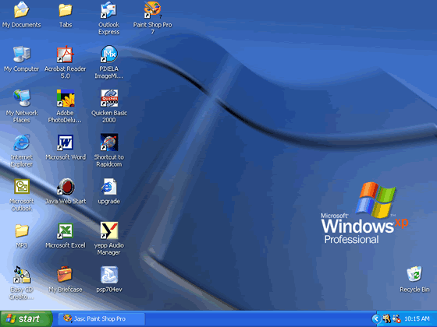

**The Start Menu**

To begin exploring Windows XP, click the **Start** button.

Start button

When you click the **Start** button, the **Start menu** appears. The **Start menu** is your gateway to the applications that are on your computer. The left side of the **Start menu** lists programs, and the right side allows access to common Windows folders (My Documents, for example). It also provides access to **Help and Support**, **Search**, and **Run**.

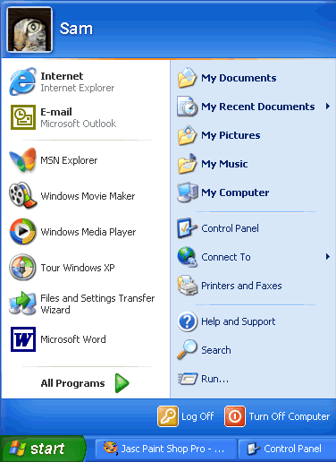

If you select **All Programs**, a pop-up menu appears. Pop-up menus like this are called **cascading menus**. If a cascading menu is available, a **small black triangle** appears next to the name of the application or function.

In the example below, the Word program has been selected.

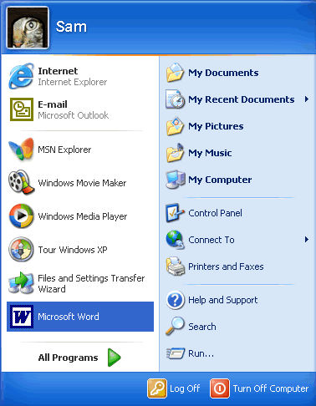

**To explore the Start menu:**

* Click the **Start** button.
* Move the mouse pointer to each option, and view the various cascading menus.
* Click (or roll your mouse pointer over) **All Programs**.
* Move the mouse pointer to the right and view other **cascading menus**.
* To exit the menus, click outside the menu area or press **Esc** on your keyboard.

http://www.gcflearnfree.org/graphics/lessons/com_lesson_check.gifThe **Start menu** remembers items you've recently opened and places the icon on the Start menu so you can easily open it next time you open the Start menu. For example, if you recently opened Microsoft Word using **Start**http://www.gcflearnfree.org/graphics/lessons/com_lesson_action.gif**All Programs**http://www.gcflearnfree.org/graphics/lessons/com_lesson_action.gif**Microsoft Word**, the next time you open the Start menu, simply click the Word icon on the left side of the Start menu.

**Understanding Icons**

The small pictures on the desktop are called **icons**. One type of icon is an **object icon**. Examples of object icons are My Computer, Recycle Bin, and Internet Explorer. These icons allow you to open files and programs on your computer.

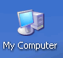

**Shortcut icons** allow you to open an application quickly. These icons appear on your desktop and with little arrow in the left corner. Desktop shortcuts are links to files and programs. You can add or delete shortcuts without affecting the programs on your computer. You'll learn about creating shortcuts in a later lesson.

Word's shortcut icon

**To open a program using an icon:**

* Place your mouse over the icon.
* Text appears identifying its name or contents.
* Then, double-click the icon.

### Understanding the Taskbar

The **taskbar** is the small blue bar you see at the bottom of your desktop. It contains the **Start menu** and the **Quick Launch bar**, which contains **icons** for Internet Explorer, Windows Media Player, and Show Desktop. Click an icon to open a program. Click Show Desktop to quickly view your desktop without closing any programs or windows.

Quick Launch toolbar

The box on the right is called the **Notification Area**. Here, you'll find the clock and several other icons depending on what you have installed on your computer. Other icons appear in the Notification Area detailing the status of your activity. For example, when you're printing a document, a printer icon appears. Microsoft also uses the Notification Area to remind you when **software updates** are available for download.

Notification Area

When you open or minimize a window or program, a **rectangular button** appears on the taskbar that shows the name of the application. These buttons disappear when you close a window. Learn more about switching between windows in lesson 4.

**Log off and Switch Users**

More than one person may use your computer. For example, many family members may use the same computer at home while several coworkers may be able to access your computer on a computer network. Windows XP allows everyone who uses your computer to have separate computer accounts. A computer accounts tracks each person's unique settings, documents, and email accounts.

Windows XP even enables you to log off the computer so someone else can log on without having to restart the computer.

**To log off/switch users:**

* Click the **Start menu** and click **Log Off**.
* A dialog box appears asking you if you want to **Switch User or Log Off**.
* **Switch User** allows someone else to log on to the computer. If you choose to Switch User, your applications will continue to run in the background while the new user logs on.
* If you choose **Log Off**, your applications will close.
* In any case, you're taken to a Windows XP logon screen where you're prompted to enter your username and password.

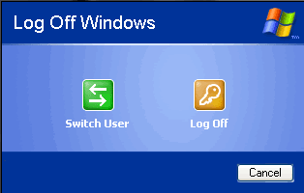

**Turn Off and Restart the Computer**

When you've finished using Windows XP, be sure to turn off (or shut down) the computer correctly.

**To turn off the computer:**

* Click the **Start menu**.
* Click **Turn Off Computer**.
* A dialog box opens. Click **Turn Off**.

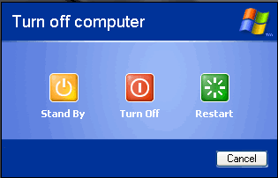

If you're experiencing computer problems or have installed something new, you can simply **restart** your computer.

**To restart the computer:**

* Click the **Start menu**.
* Click **Turn Off Computer**.
* A dialog box opens. Click **Restart**.

http://www.gcflearnfree.org/graphics/lessons/com_lesson_check.gifAlways turn off or restart your computer using this method. Do not turn off your computer by switching the power off and on. If you do so, you may damage Windows XP.

**Exploring Programs**

Programs enable you to do work on the computer. For example, a word processing programs such as Microsoft WordPad allows you to create a basic document. You can easily open a program from the Start menu using the All Programs button.

**To open a program using the Start menu:**

* Click **Start**.
* Click **All Programs** and slide your mouse pointer until you've selected the program you want to open (it turns blue).
* **Click to open** the program you've selected. (Remember, programs with small black arrows beside them will open another cascading menu. Simply drag your mouse pointer to make your selection.)
* To **close** a program, click the Close buttonlocated at the top right of the window.

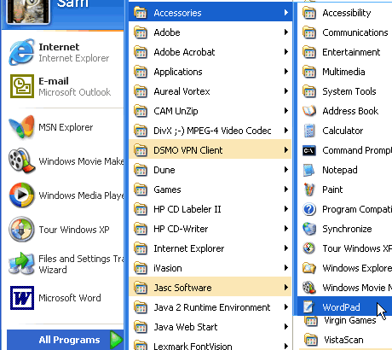

**Launching Internet Explorer from the Start menu**

**Internet**, another choice on the **Start menu**, opens **Internet Explorer**; the web browser that comes bundled with Windows XP.

**To launch Internet Explorer from the Start menu:**

* Click **Start**.
* Choose **Internet**.
* Click to open **Internet Explorer**.
* To **close** a program, click the Close buttonlocated at the top right of the window.

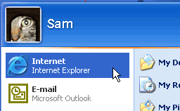

http://www.gcflearnfree.org/graphics/lessons/com_lesson_check.gif**Note:** You must be connected to the Internet for Internet Explorer to open a web page.

**Launching Microsoft Outlook Express from the Start menu**

**Email**, another choice on the Start menu, opens Microsoft Outlook Express; the email client that comes bundled with Windows XP.

**To launch Outlook Express from the Start menu:**

* Click **Start**.
* Choose **Email**.
* Click to open **Microsoft Outlook Express**.
* To **close** Outlook Express, click the Close buttonlocated at the top right of the window.

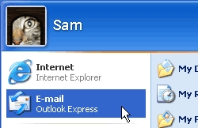

### Windows XP Bars and Buttons

Windows XP got its name from one its most basic elements: the window. The rectangular work area for a program, file, or other task is called a **window**.

Below is an example of a Microsoft Word window. While Word is a word-processing program, the example below features many of the elements common in Windows XP.

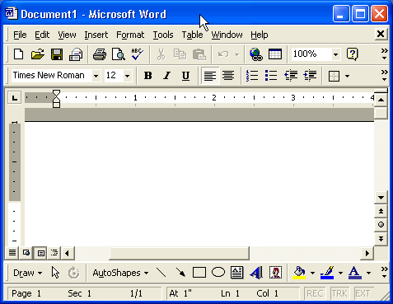

The workspace is the white area inside the window. This is where you do your work with a program, such as writing a letter. Depending on what program you're working with, the workspace will appear differently.

### More Windows XP Bars and Buttons

Windows XP offers several tools, menus, and commands that make the operating system easy-to-use.

The **title bar** is the horizontal bar at the top of a window. It's displayed as white text on blue background by default.

titlebar

The **Control menu** button is the icon at the far left end of the title bar. The Control menu button opens a menu you can use to control the window.

Control menu

The **Close** button is at the far right end of the title bar. It looks like a box with an X in it. Click the Close button to close a window or to exit a program. Next to the Close button, you'll see the Minimize and Maximize buttons. Learn more about these buttons in the next lesson.

Close button

### More Windows XP Bars and Buttons

The **menu bar** is the below the title bar. It contains several menus, which let you see a list of commands.

menu bar

Some menu options are followed by **ellipsis**, or**...** Choosing a menu option followed by an ellipses will open a dialog box, which feature helpful tools to help you perform tasks.

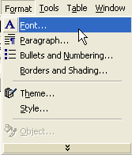

Some Windows XP programs have **toolbars** across the top of the window. The toolbar buttons allow you to print, cut, paste, or do other tasks. The options vary depending on the program.

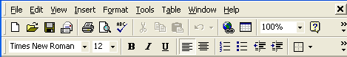

**Scrolling**

The **scroll bar** appears at the right side or the bottom of a window when all the information in that window can't be seen at the same time. Use the scroll bar to view hidden information.

The scroll bar features scroll arrows that allow you to move easily through a document. It's especially convenient when viewing a long document.

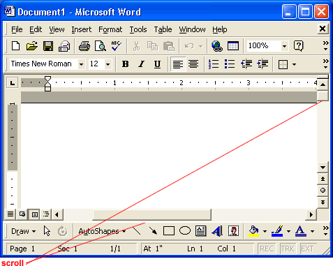

**To scroll:**

* Click the up arrow buttonarrow to scroll up.
* Click the scroll down buttonarrow to scroll down.
* Click the up double arrowarrows to scroll up one page at a time.
* Click the down double arrowarrows to scroll down one page at a time.
* Click the scroll to browsebutton to open a browse menu.

OR

* Click and drag the scroll bars to view your document.

### Minimizing, Maximizing, and Restoring Windows

Windows allows you to easily enlarge, hide, or shrink a window using the **Minimize, Maximize, and Restore** buttons.

The **Minimize** button is among the three buttons at the right end of the title bar. This button has a small dash (or minus sign). The Minimize button shrinks the window and places it on the taskbar while leaving the program running.

The **Maximize** button, which looks like a small window, is used to enlarge a window to cover the entire desktop.

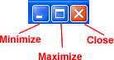

After a window is maximized, the Maximize button changes to the **Restore** button. It looks like two windows near one another. If you click the Restore button, the maximized window shrinks to its previous size (the size it was before you maximized it).

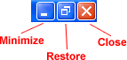

**Sizing Windows**

Sizing window is slightly different from minimizing, restoring, or maximizing. **Note:** You cannot size a window if it's been maximized.

**To change the size of a window:**

* Hover the mouse pointer over **any corner of the window**. (You can also place the pointer over the **borders** of the window.)
* The mouse pointer changes into a **double-headed arrow**.
* **Click**and **hold down** the left mouse button.
* **Drag** the arrow out or in to make the window larger or smaller.
* **Release** the mouse button when the window is the size you want.

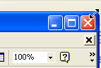

http://www.gcflearnfree.org/graphics/lessons/com_lesson_check.gifMake sure the mouse pointer change into a two-headed arrow before you try to size the window.

**Moving a Window Using the Title Bar**

Sometimes a window may obscure an item you want to click on or view.

**To move a window:**

* Place the mouse pointer over the **title bar** (at the top of the window).
* Click and hold down the **left** mouse button. (You cannot move a window that has been maximized other than to use the Minimize button.)
* **Drag** the window to the place where you want it and **release** the mouse button.

titlebar

**Tiling and Cascading Windows**

Sometimes, moving and sizing multiple windows can create confusion. To keep better track of multiple windows, try **cascading** or **tiling** the windows.

http://www.gcflearnfree.org/graphics/lessons/com_lesson_arrow.gif**Cascading windows** are **layered** on top of each other.

http://www.gcflearnfree.org/graphics/lessons/com_lesson_arrow.gif**Tiled windows** are next to each other. Windows can be tiled horizontally or vertically. If windows are tiled horizontally, they appear one above another. If windows are tiled vertically, they appear side by side.

**To cascade or tile windows:**

* With two or more windows open, **right-click** on a blank area of the taskbar.
* Choose **Cascade Windows, Tile Windows Horizontally, or Tile Windows Vertically**.

**To return to your previous window arrangement:**

* **Right-click** on a blank area of the taskbar.
* Select the **Undo** command.

**To show the desktop:**

* **Right-click** on a blank area of the taskbar.
* Choose **Show the Desktop**.

**Switching Between Windows**

Windows XP allows you to have more than one program open at the same time. It also allows you to easily move between open windows. The window you select becomes the active window. When a window is active on the desktop, its title bar (and button on the taskbar) is blue. When a window is inactive, the title bar is light blue.

**To switch between windows:**

* Open **more than one** program.
* **Size** the windows so they're **open on the desktop**.
* **Click on any part of the window** you want to work with.

OR

* Click the program buttons on the **taskbar** to activate the window you want to work with.

Unlike previous versions of Windows, Windows XP keeps the taskbar from getting too cluttered. It **groups the buttons** when too many accumulate on the taskbar. For example, when you open Outlook Express, you'll see one button on the taskbar. However, if you have three or more email message windows open, one button represents the Outlook Express's open windows.

Simply click the button to select from the pop-up list of open windows.

taskbar button



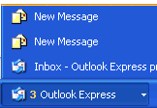

**Switching Using the Keyboard Method**

When you have more than one window open, you can also switch between them using the **keyboard**.

**To switch between window using the keyboard method:**

* Open **more than one** program or window.
* Press and hold down the **Alt** key while pressing the **Tab** key.
* A **menu** featuring file and program icons appear.
* **Tab** to the window you want to view. Once it's outlined with a box, release both keys.

**Introduction to the Control Panel**

You don't have to be a computer genius to use Windows XP, but if you know something about how to set up some basic features and functions, it will do a lot more for you. Windows XP makes this easier than ever with the **Control Panel**. The Control Panel features a number of tools that will help you control how Windows XP features look and act. But first you must learn how to access the Control Panel.

**To access the Control Panel:**

* Click **Start**.
* Click **Control Panel**.
* The **Control Panel** opens.

OR

* Type **Control Panel** in the **Address** dialog box found on any Windows XP window.

OR

* Many **folders** feature a **link** to the Control Panel in the **See Also** dialog box (only in XP view).

No matter how you get to the Control Panel, it will look like this upon first viewing:

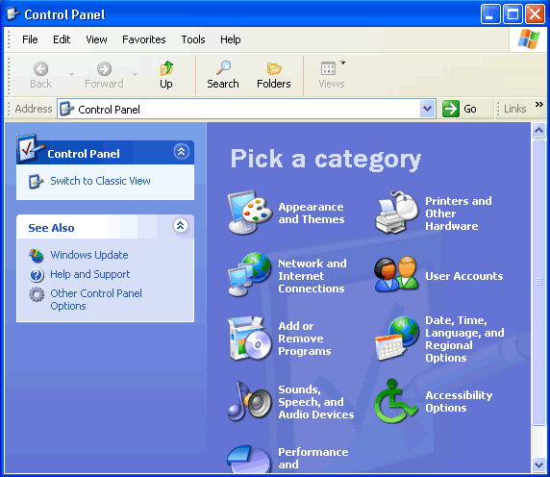

**Navigate the Control Panel**

If you're used to a previous version of Windows, you'll notice that the Control Panel in Windows XP looks very different.

The Windows XP Control Panel is divided into **Categories**. If you click a Category, the window presents a **List of Tasks** and related **Control Panel icons**.

**Note: Task and Control Panel icons perform basically the same functions**. For example, notice that you can "Choose a screen saver" in the Pick a Task list. Clicking this link opens the **Display Properties** dialog box. However, if you were to choose the **Display** icon, the **Display Properties** dialog box opens.

If you look at the left side of the window, you'll notice that the **See Also** and **Troubleshooters** dialog boxes provides several more related options.

The **new Control Panel design** provides multiple ways to do something, thereby making it more user-friendly. However, the new Control Panel design **doesn't provide you with access to every available Control Panel tool** - it only provides you access to the most commonly used tools.

To access **ALL** of your Control Panel tools, you must switch to **Classic View**.

**To switch to Classic View:**

* Click the **Classic View** link on the left side of your Control Panel.
* Click the **Switch to Category View** link to switch back.

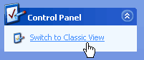

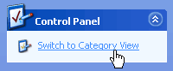

http://www.gcflearnfree.org/graphics/lessons/com_lesson_check.gifUse the menu bar and toolbar buttons to navigate and further explore Control Panel options.

**Set the Time and Date**

In the following pages, we'll explain how to perform some common Control Panel tools.

**To change the time and date:**

1. Open the **Control Panel** (located in Start menu).
2. Under Pick a Category, click **Date, Time, Language, and Regional Options**.
3. Under Pick a Task, click **Change the date and time**.
4. The **Date and Time Properties** dialog box opens.
5. Use the **drop down box** to set the month and year.
6. Click the correct date on the calendar.
7. Click and select the current time to make a change.
8. If necessary, click the **Time Zone** tab and use the drop down box to change the time zone.
9. Click **OK** to close the dialog box.

OR

1. **Right-click** the time in the lower right on your desktop.
2. Choose **Adjust Date/Time**.
3. The **Date and Time Properties** dialog box opens.
4. Follow above steps 5-9.

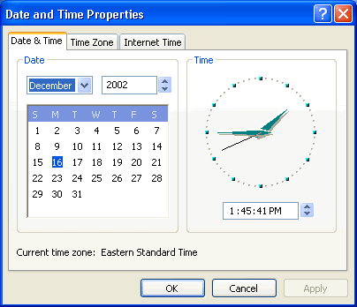

**Changing the Wallpaper**

**Wallpaper** is the background image that appears on your desktop. Windows XP offers many wallpaper choices.

**To change the wallpaper:**

* Open the **Control Panel** (located in Start menu).
* Under Pick a Category, click **Appearance and Themes**.
* Under Pick a Task, click **Change the desktop background**.
* The **Display Properties** dialog box opens with the Desktop tab selected.
* In the **Background** box, click or use the arrow keys to view the choices.
* Use the drop down boxes to alter wallpaper **position** or **color**.
* Click OK to close the dialog box.

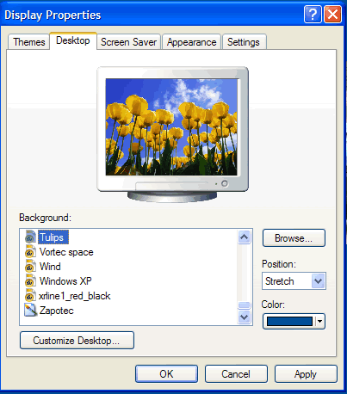

**Advanced Users:**

* Click Browse to choose a picture from the **My Pictures** folder (or navigate to a picture located in another folder.)
* Click the **Customize Desktop** button to alter your desktop icons or display a web page on your desktop.

**Changing the Screensaver**

In the early days of computing, **screen savers** helped prevent images from being burned into the monitor. Now, screen savers entertain us, provide some privacy, and enhance or work or home environment. Windows XP comes with several screen savers.

**To change the screensaver:**

* Open the **Control Panel** (located in Start menu).
* Under Pick a Category, click **Appearance and Themes**.
* Under Pick a Task, click **Choose a screen saver**.
* The **Display Properties** dialog box opens with the **Screen Saver** tab selected.
* Click the **arrow** to open a drop down box. Click or use the arrow keys to view the choices. Or, click **Preview** to view each option on your computer screen. Press any key on your keyboard to return to the dialog box.
* Click **Settings** to customize the appearance or your chosen screen saver.

(A dialog box will notify you if your choice doesn’t have any options.

* In the **Wait** box, determine how many minutes should pass before your screen saver turns on.
* Click **OK** to close the dialog box.



**Customizing the Taskbar**

You already know about the Taskbar, but did you know you can customize its appearance?

**To customize the Start menu:**

* Open the Control Panel (located in Start menu).
* Under Pick a Category, click Appearance and Themes.
* Under Pick a Control Panel icon, click Taskbar and Start Menu.
* The Taskbar and Start Menu Properties dialog box opens with the Taskbar tab displayed.
* Use the checkboxes to customize its appearance and click OK.

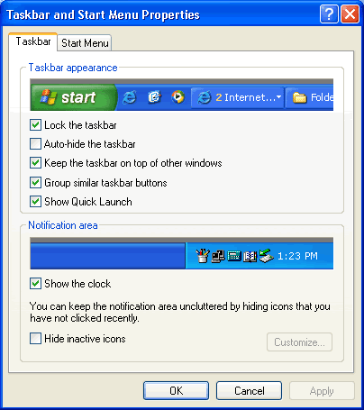

http://www.gcflearnfree.org/graphics/lessons/com_lesson_check.gifClick the **Start Menu** tab to switch between the **XP Start menu** and **Classic Start menu**. Classic Start menu is the Start menu featured in older versions of Windows.

**What is a File?**

**Files** are collections of information. In fact, almost all of the information stored in a computer is stored in a file. There are many different types of files, including operating system files, program files, and your own files.

Different types of files store different types of information. Each file is given a **filename** and has a three-letter **filename extension** that identifies the file type. (The filename and filename extension are separated by a period.) For example, a document created using WordPad might have the file name, **letter to John.doc**.

**Some common file name extensions are:**

* **doc**: Word or WordPad document
* **txt**: Notepad text file
* **eml**: Email file
* **xls**: Excel spreadsheet
* **htm or html**: HTML file (web page)
* **ppt** : PowerPoint presentation
* **mbd**: Access database

**Creating, Renaming, and Deleting Files**

With Windows XP, you can create a **file** using different programs such as WordPad or Notepad.

**To create a file using Notepad:**

* Click **Start**.
* Choose **All Programs**http://www.gcflearnfree.org/graphics/lessons/com_lesson_action.gif**Accessories**http://www.gcflearnfree.org/graphics/lessons/com_lesson_action.gif**Notepad**.
* Notepad opens.
* Type, **"This is my new document."**
* Choose **File**http://www.gcflearnfree.org/graphics/lessons/com_lesson_action.gif**Save** from the menu bar (Ctrl + S).
* The **Save As** dialog box appears.
* **Save** your file to the **desktop**.
* **Name** your document **new document**.
* In the **Save as type** drop down box, be sure your document is saved as a **text** document.
* Click **Save**. Your file is now saved to the desktop.

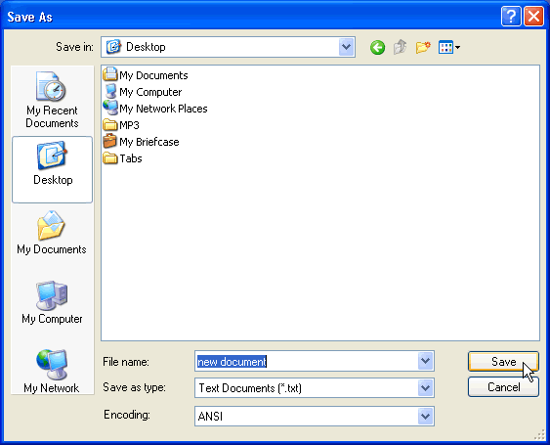

Once you've created a file, you can **rename** it.

**To rename a file:**

* Locate your file (in this case, the file is located on the desktop).
* **Right-click** the file icon.
* Choose **Rename**.
* The filename is **highlighted in blue**, ready to be retyped.
* **Type a new name** and press Enter.
* The file is **renamed**.

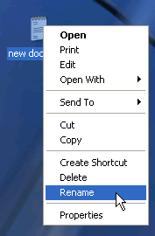

You can also **delete** files.

**To delete a file:**

* Locate your file (in this case, the file is located on the desktop).
* **Right-click** the file icon.
* Choose **Delete**.
* A **Confirm File Delete** dialog box appears asking you if you are sure you want to send the file to the Recycle Bin.
* Choose **Yes**.
* The file is moved to the **Recycle Bin**.

**What is a Folder?**

When you first start using Windows XP, you may only create a few files. Over time, you'll create **MANY** files. To keep your files organized, create **folders**. Windows XP uses various folders to store and manage **files**. To become more familiar with the structure of a Windows XP folder, let's open a folder called **My Documents**.

**To open and view the contents of the My Documents folder:**

* Double-click the **My Documents icon** on the desktop.
* The **My Documents folder** opens.

OR

* **Right-click** the **My Documents icon** (on the desktop).
* Choose **Open**.

OR

* Open the **Start menu**and choose **My Documents**.

**Your My Documents folder looks something like this:**

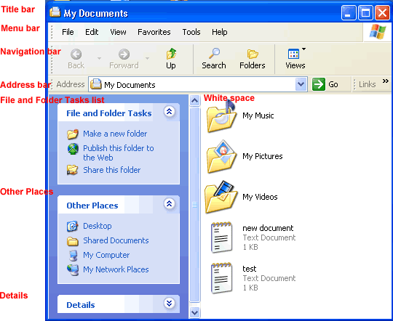

**All Windows XP folders include the following features:**

* **Title bar**:contains the name of the folder
* **Menu bar**: contains the File, Edit, View, Favorites, Tools, and Help menus.
* **Navigation bar**: contains the Back, Forward, Up, Search, Folders, and Views buttons.
* **Address bar**: shows current folder location. Use the drop down arrow to navigate your computer's places.
* **White space**: displays contents of the folder (folders and files)
* **File and Folder Tasks list**: a convenient list of tasks
* **Other Places**: convenient list of your computer's places
* **Details**: describes the folder

**Creating, Renaming, and Deleting Folders**

At some point, you may want to create a folder within a folder. Here, practice creating a **Job Search folder** in the **My Documents folder**.

**To create a new folder in the My Documents folder:**

* Open **My Documents**.
* Choose **File**http://www.gcflearnfree.org/graphics/lessons/com_lesson_action.gif**New**http://www.gcflearnfree.org/graphics/lessons/com_lesson_action.gif**Folder**.
* A **new folder icon** appears in My Documents, with its name highlighted. (The default is New Folder.)
* Type a **new, more descriptive name** and click Enter.

Creating a new folder via the File menu

OR

* Open **My Documents**.
* Choose the **Make a New Folder link** from the File and Folder tasks menu.

Make a new folder link

**To rename a folder:**

* Locate your folder.
* **Right-click** the folder icon.
* Choose **Rename**.
* The folder name is **highlighted in blue**, ready to be retyped.
* **Type a new name** and press Enter.

OR

* Open your folder.
* Click the folder icon.
* Choose **Rename this folder** from the File and Folder Tasks menu.

**To delete a folder:**

* Locate your folder.
* **Right-click** the folder icon.
* Choose **Delete**.
* A **Confirm Folder Delete** dialog box appears asking you if you are sure you want to send the file to the Recycle Bin.
* Choose **Yes**.
* The folder is moved to the **Recycle Bin**.

OR

* Open your folder.
* Click the folder icon.
* Choose **Delete this folder** from the File and Folder Tasks menu.

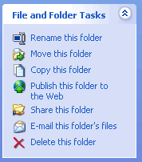

**What is a Drive?**

A **drive, or disk drive**, is hardware on which you can store files and folders. Disk drives are assigned a **letter**.

* Your hard drive (the drive inside your computer) is known as the (C:) drive.
* Your floppy disk drive is known as the (A:) drive.
* If your computer has a CD ROM drive, it is usually called (D:)

### Introduction to My Documents

**My Documents** is a **folder** that provides you with a convenient place to store your important files and folders. Remember, you can quickly reach **My Documents** in the Start menu or by double-clicking the My Documents icon on your desktop.

My Documents icon

##### The My Documents folder looks something like the example below:



My Documents includes a few **default subfolders** called **My Music**, **My Pictures**, and **My Videos**. Feel free to use, rename, or delete these folders.

http://www.gcflearnfree.org/graphics/lessons/com_lesson_check.gif**Very important!** When you save a file, the file is automatically saved in My Documents unless you've chosen a different folder or drive.

**Exploring Windows Explorer**

**Windows Explorer** is a **file management tool** that lets you **create, rename, and delete folders**. It also allows you to **copy, print, move, delete, rename, and manage files**.

**To open Windows Explorer:**

* Open **My Documents**.
* Click the **Folders** button on the **Navigation** toolbar.
* A **list of folders** opens in the **left pane**.

**To explore Windows Explorer:**

* With **Windows Explorer open**, scroll until you see the **Control Panel icon** in the left pane.
* Click the **Control Panel icon**. The contents (of the Control Panel folder) display in the **right pane**.
* Practice viewing other folders in the list.
* To **close Windows Explorer**, click the **small black X** in the upper right of the list OR click the **Folder** button.

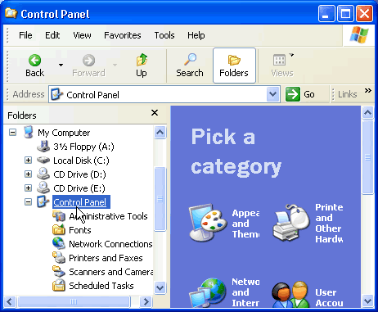

**Exploring My Computer**

**My Computer** is another tool you can use to manage files and folders. With this tool, you can **create, rename and move folders** and **copy, print, move, delete and rename files**. It also allows you to gain **access** to other system tools.

**To open My Computer:**

* Double-click the **My Computer icon** on the desktop.   
  
* **My Computer** opens.

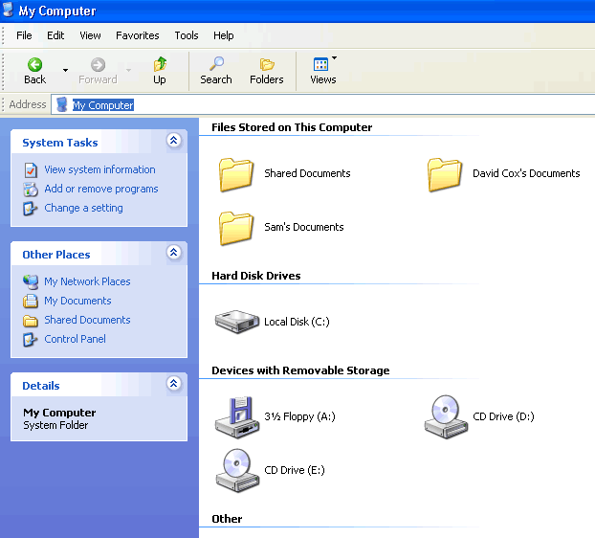

OR

* **Right-click** the **My Computer icon** (on the desktop).
* Choose **Open**.

OR

* Open the Start menu and choose **My Computer**.

**Copying Files and Folders**

Windows offers several ways of working with files and folders. **Copying** and **moving** are two useful techniques.

**To copy a file or folder:**

* Open **My Documents**. Locate the file or folder you want to copy in My Documents or its subfolders.
* Click the **file or folder** you want to **copy**. The file or folder darkens when you select it.
* Under File and Folder Tasks, click **Copy this file** or **Copy this folder**.
* In the **Copy Items** dialog box, select the place where you want to copy the file or folder.
* Click the **Copy** button.

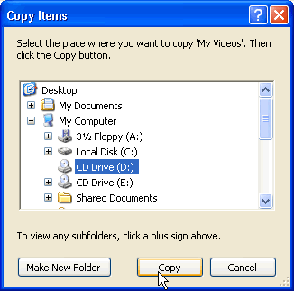

OR

* Choose **Edit**http://www.gcflearnfree.org/graphics/lessons/com_lesson_action.gif**Copy**. (Ctrl + C)

OR

* **Right-click** the file or folder and choose **Copy**.

THEN

* Locate the file or folder you want to copy and choose **Edit**http://www.gcflearnfree.org/graphics/lessons/com_lesson_action.gif**Paste**. (Ctrl + V)

OR

* **Right-click** the file or folder and choose **Paste**.

**Moving Files and Folders**

**Moving files and folders** is relatively easy using **My Computer** or **Windows Explorer**.

**To move files and folders:**

* Open **My Documents**. Locate the file or folder you want to move in My Documents or its subfolders.
* Click the **file or folder** you want to **move**. The file or folder darkens when you select it.
* Under File and Folder Tasks, click **Move this file** or **Move this folder**.
* In the **Move Items** dialog box, select the place where you want to move the file or folder.
* Click the **Move** button.

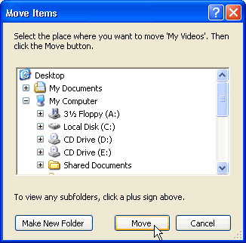

OR

* Choose **Edit**http://www.gcflearnfree.org/graphics/lessons/com_lesson_action.gif**Cut**. (Ctrl + X)

OR

* **Right-click** the file or folder and choose **Cut**.

THEN

* Locate the file or folder you want to copy and choose **Edit**http://www.gcflearnfree.org/graphics/lessons/com_lesson_action.gif**Paste**. (Ctrl + V)

OR

* **Right-click** the file or folder and choose **Paste**.

**Selecting More Than One File Or Folder**

You may need to copy or move **multiple files and folders**.

**To copy or move more than one file or folder:**

* Hold down the **Ctrl key** and click to select the files or folders you want to move or copy.
* The files or folders darken as they are selected.
* Copy or move the file or folder using one of the methods explained on the previous pages.

http://www.gcflearnfree.org/graphics/lessons/com_lesson_check.gifTo select a consecutive group of files, click the first file, press and hold down the Shift key, and click the last file. All of the files will be selected.

**Choosing Views**

You can choose how you want to **display** files and folders. Display them as **thumbnails, tiles, large icons, small icons, as a list, or as a list with details including size, type and date last modified**.

**To choose the view for your files or folders:**

* Open **My Documents**.
* Click the **Views** button.
* A drop down menu appears. Choose your view.
* A **large black dot** appears next to your current choice.

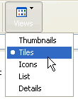

OR

* Open the **View menu** and choose your view.

### What is a Shortcut?

A **shortcut** offers a way of doing a task more quickly such as starting a program or accessing a document. The shortcut icon has a **small arrow in the left corner** to help you distinguish it from the actual icon that represents programs and files.

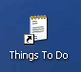

The icon above is a desktop shortcut for the **Things to Do** document that's actually stored in this particular user's My Documents folder.

http://www.gcflearnfree.org/graphics/lessons/com_lesson_check.gifWhen you **delete** a shortcut, the original item still exists on your computer in its original location.

**Adding a Shortcut**

In this lesson, you will learn three ways to create a **shortcut**. Choose the one that works best for you.

**To add a shortcut to the desktop using Windows Explorer or My Computer:**

* Open **Windows Explorer** or **My Computer**.
* Double-click a **drive** or **folder**.
* Click the file, program, or folder for which you want to make a shortcut. The item darkens when you select it.
* Choose **File**http://www.gcflearnfree.org/graphics/lessons/com_lesson_action.gif**Create Shortcut**.
* **Resize the window** so you can see the **desktop**.

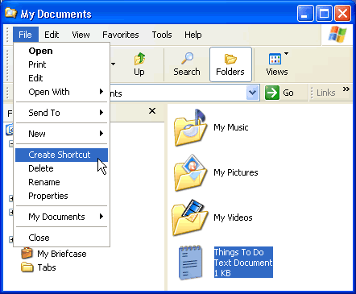

* **Hover** the mouse pointer over the shortcut icon and **hold down** the left mouse button and **drag** the shortcut onto desktop (in the left pane).
* **Release** the left mouse button and a shortcut is moved to the desktop.

http://www.gcflearnfree.org/graphics/lessons/com_lesson_check.gifAlternatively, press **Ctrl + Shift** while dragging the file to the desktop to create a shortcut.

**Right-click to Add a Shortcut**

One shortcut creation method works in both **My Computer** and **Windows Explorer**. This method requires you to **right-click**.

**To add a shortcut by right-clicking:**

* Open **Windows Explorer** or **My Computer**.
* Double-click a drive or folder.
* **Right-click** the file, program, or folder for which you want to make a shortcut.
* A pop-up menu appears. Choose **Create Shortcut**.
* Resize the window so you can see the desktop.

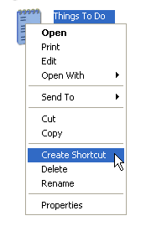

* **Hover** the mouse pointer over the shortcut icon and **hold down** the left mouse button and **drag** the shortcut onto desktop (in the left pane).
* **Release** the left mouse button and a shortcut is moved to the desktop.

### What is the Recycle Bin?

Sometimes files and folders can clutter your computer. The **Recycle Bin**, the desktop icon that resembles a wastebasket, is where you put a file or folder if you want to **delete** it.

You can open the Recycle Bin anytime and see what's inside by **double-clicking** the **Recycle Bin icon** located on the desktop or using Windows Explorer.

Inside, you'll see a listing of deleted items.

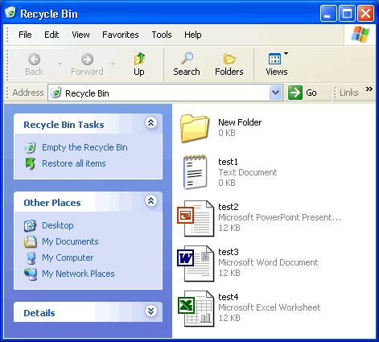

**Placing Files in the Recycle Bin**

**To move an item to the Recycle Bin from the Desktop, Windows Explorer, or My Computer:**

* **Click and drag** the file or folder to the **Recycle Bin**.

OR

* **Right-click** the file or folder you want to delete. .
* When the pop-up menu appears, choose **Delete**.
* A dialog box appears asking, "Are sure you want to send the file or folder to the Recycle Bin?"
* Click **Yes**.

OR

**To move an item to the Recycle Bin from Windows Explorer or My Computer:**

* Click the file or folder you want to delete.
* The file or folder darkens.
* Choose **Delete this file (or Delete this folder)** from the File and Folder Tasks list.

**Retrieving Files From the Recycle Bin**

Placing an item in the Recycle Bin doesn't mean you can't retrieve it at a later date. Using the **Restore all items link** (located in the Recycle Bin Tasks list) will move all files and folders in the Recycle bin back to its **original location**on your computer.

**To restore all items in the Recycle Bin:**

* Click the **Restore all items** link in the Recycle Bin Tasks list.
* The items are restored to their **original location**.

**To restore one file, click to select the file.**

* **Restore all items** changes to **Restore this item**.
* Click **Restore this item**.
* The item is restored to its **original location**.

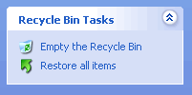

**Emptying the Recycle Bin**

Emptying the Recycle Bin **permanently deletes** the items. They cannot be recovered. Empty your Recycle Bin periodically to keep your computer running smoothly.

**To empty the Recycle Bin:**

* Click the **Empty the Recycle Bin** link in the Recycle Bin Tasks list.



**Opening the Search Companion**

When you have trouble finding a file or folder on your computer, search for it using Microsoft XP's **Search Companion**.

**To open the Search Companion:**

* Open and Start menu and choose **Search**.

OR

* Open **My Documents** and click the **Search** button.

OR

* Open **My Computer** and click the **Search** button.
* The **Search Companion** opens in the left pane and presents the **following list of options:**

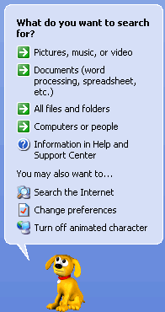

**Using the Search Companion**

Depending on what option you choose, you're presented with various ways to conduct your search.

Let's say you choose to search All Files and Folders linkfor a particular file. The Search Companion prompts you with questions to help you refine your search. It's helpful if you can remember something about the missing file such as all or part of the filename, file type, when you last worked with the file, a word or phrase in the file, or what drive it's on, etc. The more criteria contained in your search, the more refined the search becomes.

**To search using the Search Companion:**

* Enter **as much information as you can remember** into the Search Companion.
* Click the **drop down arrows** to add more criteria.
* Use the **Back** button if necessary.
* Click **Search**.

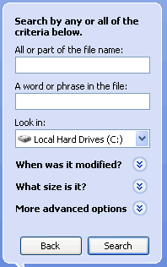

**Using the Search Companion (Continued)**

* Once you click **Search**, the Search Companion tells you what it's searching.
* Your search results **display** in the **white space**.
* The Search Companion tells you when the search is complete and prompts you with more **Search options**.
* If your search is complete, click **Yes, finished searching**.
* Simply double-click the file to open it.

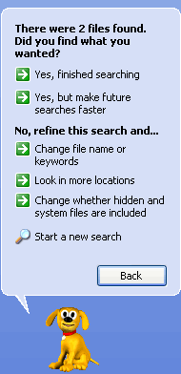

Finding a file can take seconds, minutes or much, much longer depending on the type of search and where you look. If you don't find the file or folder you're looking for on the first try, type in a different name and/or location.

http://www.gcflearnfree.org/graphics/lessons/com_lesson_check.gifTo quickly review files listed in your search results, hover your mouse pointer over the filename. A **yellow pop-up window** displays, telling you its **location, the file type, and size**. Double-click the file to open it.

**Previewing Image Files**

You can preview **image documents** (including fax documents) using the **Windows Picture and Fax Viewer** without opening an image editing program. This is especially useful when browsing through a list of non-descriptive filenames. For example, let's say you have a file named **09786.jpeg**. You may wonder what the file looks like.

**To preview an image file:**

* **Right-click** the file and choose **Preview** from the pop-up menu.
* The **Windows Picture and Fax Viewer** opens, displaying the image file.
* Use the **control buttons** at the bottom of the window to perform basic tasks without opening an image editing program.
* Use the **arrow buttons** to view images as a slideshow.

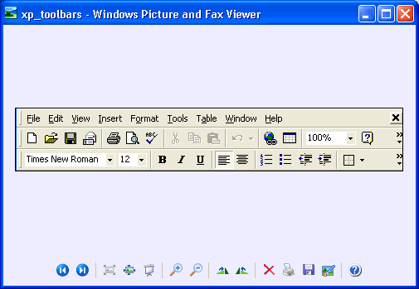

**Understanding User Accounts**

A user is someone who uses a computer. A user account defines what a user can do using Windows XP. In Windows XP, there are three types of user accounts.

1. **Administrator account.** The administrator can do everything with the computer and can go anything he or she desires - essentially giving them control over the entire computer, including other accounts. The administrator account can never be disabled or deleted.
2. **Standard account.** Users with standard accounts can install programs and hardware, change pictures and related personal data, and create, change, or remove his or her password.
3. **Guest account.** The guest account doesn't require a password, can't add or remove programs from the computer, and is disabled by default. This account type is great for kids or students.

### Managing User Accounts

To easily manage user accounts, click the **User Accounts** icon in the Control Panel.



The **User Accounts** window presents you with an easy-to-use interface.

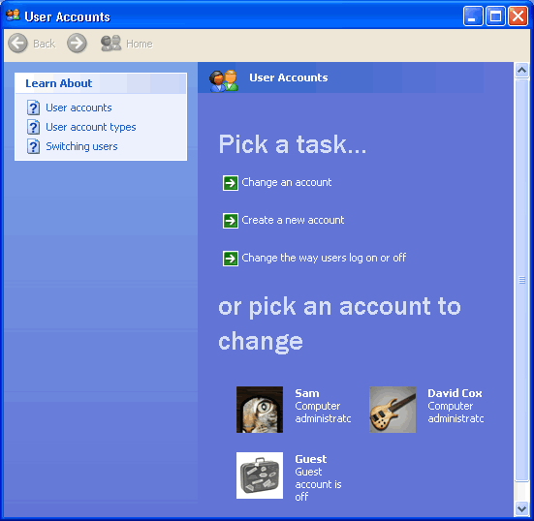

**Creating a New Account**

You can **create new user accounts** as needed, giving others access to your computer (without sharing your password).

**To create a new account:**

* Click **Create a New Account** in the **User Accounts** window.
* A **User Accounts** window appears. Enter the **name** of the new account and click **Next**.
* The next window asks you to pick an account type. Choose **Computer Administrator** or **Limited** by clicking the appropriate radio button.
* If you're not sure, click each one and read the list of actions that can be performed by the account type.
* When finished, click the **Create Account** button.
* The **new account** now appears in the **User Account** window.

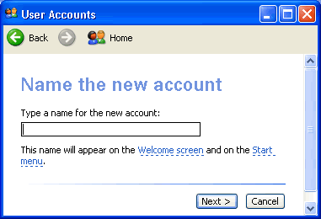

**Changing An Account**

Any account can be easily **edited or changed** from the **User Accounts** window.

**To change an existing user account:**

* Click **Change an Account** in the **User Accounts** window.
* A window appears asking you which account you want to change.
* The next window (figure below) allows you to change the name on the account, change the picture, change the account type, create a password, or delete the account. Make necessary changes.
* Use the **Back** button to return to the original list to make any additional changes.

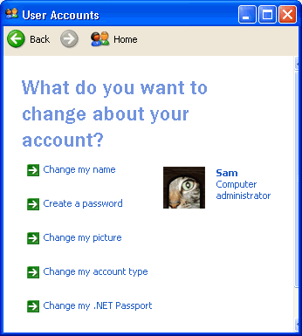

http://www.gcflearnfree.org/graphics/lessons/com_lesson_check.gifPasswords provide security and prevent unauthorized users from logging in using someone else's user account. For more information on passwords, see our Internet Basics course.

**Changing User Log on/Log off Procedures**

You can also select the way users **log on and log off**.

**To change log on and log off options:**

* Click **Change the way users log on and off** in the User Accounts window.
* You'll see two checkboxes that allow you to enable the **Welcome screen** and **Fast User Switching**. **Fast User Switching** allows you to switch to another user account without closing any programs.

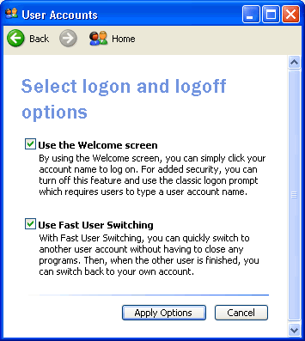

**Accessibility and the Accessibility Options Dialog Box**

As you know, a computer functions with both **input** (keyboard and mouse, for example) and **output** (monitor and printer, for example) **devices**. In this lesson, we'll focus on how Windows XP allows you to configure your computer's input and output behaviors to accommodate people with a range of disabilities.

**To access the Accessibility Options dialog box:**

* Open the **Control Panel**.
* Click the **Accessibility Options** link.



* The **Accessibility Options** window opens.
* Under **Or pick a Control Panel icon**, click the **Accessibility Options** link.
* The **Accessibility Options** dialog box opens.

### Adjusting the Keyboard

When you open the **Accessibility Options** dialog box, notice that it is equipped with five tabs: **Keyboard, Sound, Display, Mouse, and General**.

The **Keyboard** tab allows you to change the way your keyboard inputs information into Windows XP.

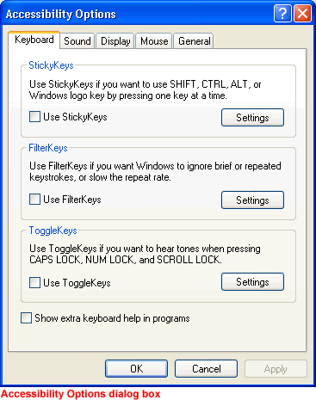

##### The following features are especially helpful for users who have difficulty using the keyboard.

http://www.gcflearnfree.org/graphics/lessons/com_lesson_arrow.gif**StickyKeys**. Enable StickKeys so you don't have to hold down several keys at once on the keyboard. For example, if you want to use Control + Alt + Delete, StickKeys allows you to press one key at a time rather than having to hold them down all at once. To use StickKeys, check the Use **StickyKeys** box and press the **Settings** button to adjust your personal settings. Once you enable or disable these, you can use them by pressing the **Shift** key five times in a row.

http://www.gcflearnfree.org/graphics/lessons/com_lesson_arrow.gif**Filterkeys**. Enable FilterKeys to ignore brief or repeated keystrokes. To use FilterKeys, click the **Use Filterkeys** checkbox and click the **Settings** button to adjust your personal settings.

http://www.gcflearnfree.org/graphics/lessons/com_lesson_arrow.gif**Togglekeys**. Enable ToggleKeys if you want to hear tones when pressing CAPS LOCK, NUM LOCK, and SCROLL LOCK. To use ToggleKeys, click the **Use ToggleKeys** checkbox and click the **Settings** button to adjust your personal settings.

### Adjusting the Sound

The **Accessibility Options Sound tab** allows you to enable Windows sounds to help you operate Windows XP.

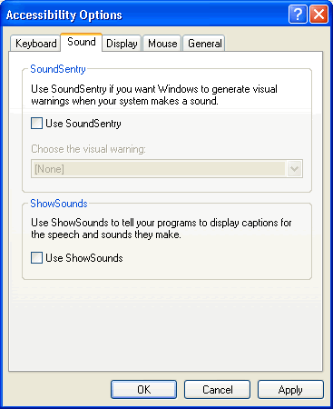

##### These features are especially helpful for users who are hearing impaired. Choose from two options:

http://www.gcflearnfree.org/graphics/lessons/com_lesson_arrow.gif**SoundSentry**. Windows XP uses sound to alert the user to certain warnings or notices. Sound Sentry enables these warnings to appear on your screen instead of as a sound. To use **Sound Sentry**, click the **Use SoundSentry** checkbox. Then choose the kind of visual warning you want to receive.

http://www.gcflearnfree.org/graphics/lessons/com_lesson_arrow.gif**ShowSounds**. Use ShowSounds to tell any programs to show text for any sounds or speech they may use. To use **ShowSounds**, click the **Use ShowSounds** checkbox.

### Adjusting the Display

The **Display tab** allows you to use **high-contrast colors** and **adjust the cursor** to make reading easier.

##### These features are especially helpful for users who are visually impaired. Choose from two options:

http://www.gcflearnfree.org/graphics/lessons/com_lesson_arrow.gifTo enable **High Contrast**, click the **Use High Contrast** checkbox. Clicking the **Settings** button enables the shortcut for High Contrast, **ALT+SHIFT+PRINT SCREEN**.

http://www.gcflearnfree.org/graphics/lessons/com_lesson_arrow.gifUse the **sliders** to change the cursor blink rate and the width of the cursor.

### Using MouseKeys

The **Mouse tab** allows you to use the numeric keypad on your keyboard to control the pointer. To use **MouseKeys**, click the **Use MouseKeys** checkbox. Clicking the **Settings** button enables the shortcut for MouseKeys, **LEFT ALT+LEFT SHIFT+NUM LOCK**.

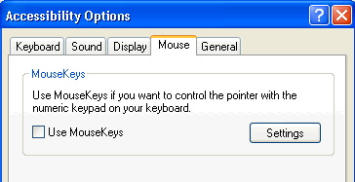

### The General Tab

The **General tab** provides some other **accessibility control options**.

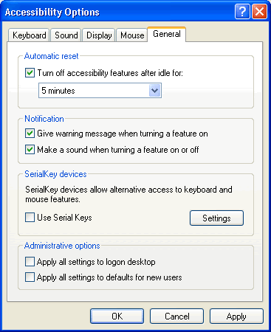

http://www.gcflearnfree.org/graphics/lessons/com_lesson_arrow.gif**Automatic reset**. If accessibility features are turned on, users can turn off accessibility features after being idle for a specific period of time. Use the drop down menu to select the desired time.

http://www.gcflearnfree.org/graphics/lessons/com_lesson_arrow.gif**Notification**. Receive a warning when turning a feature on or make a sound when turning a feature on or off.

http://www.gcflearnfree.org/graphics/lessons/com_lesson_arrow.gif**SerialKeys**. Turn on SerialKeys so other input devices (other than the traditional keyboard and mouse) can work with Windows XP.

http://www.gcflearnfree.org/graphics/lessons/com_lesson_arrow.gif**Administrative options**. Computer administrators can apply all accessibility options to the logon desktop and apply all accessibility settings for each new user.

**What is the Accessibility Wizard?**

**Wizards** are helpful programs that lead you through a series of steps. Usually, each step asks you to input some information and then uses that information to accomplish a certain task. Microsoft Windows XP's **Accessibility Wizard** allows you to customize your computer with tools designed to help meet your vision, hearing, or mobility needs.

**To open the Accessibility Wizard:**

* Choose **Start**http://www.gcflearnfree.org/graphics/lessons/com_lesson_action.gif**All Programs**http://www.gcflearnfree.org/graphics/lessons/com_lesson_action.gif**Accessories**http://www.gcflearnfree.org/graphics/lessons/com_lesson_action.gif**Accessibility**http://www.gcflearnfree.org/graphics/lessons/com_lesson_action.gif**Accessibility Wizard**.
* The **Accessibility Wizard** opens.

OR

* Open the **Control Panel**.
* Click the **Accessibility Options** link.
* The **Accessibility Options** window opens.
* Under Pick A Task, click **Configure Windows** to work for your vision, hearing, and mobility needs.
* The **Accessibility Wizard** opens.

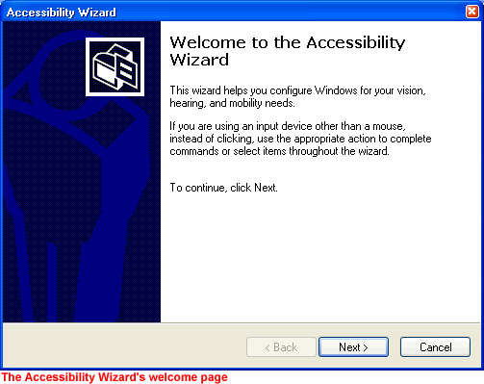

http://www.gcflearnfree.org/graphics/lessons/com_lesson_check.gifWhile Windows XP provides basic accessibility tools to users with special needs, many users with disabilities purchase additional programs and devices to aid in their daily computer use.

### The Text Size Page

Once you've successfully opened the **Accessibility Wizard**, click **Next** to beyond the welcome screen.

In the **Text Size** window, click or use the arrow keys to select the smallest text you can read. Click **Next**.

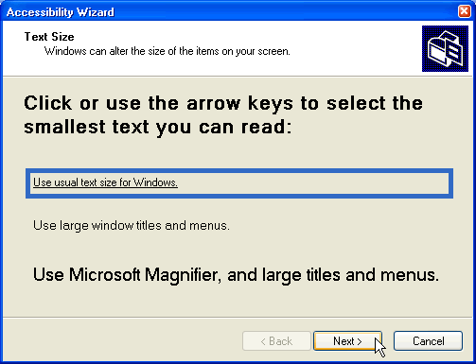

### The Display Settings Page

On this page, you'll see some checkboxes that allow you to select how your **display** appears. You can choose to change the **font size**, use **Microsoft Magnifier**, and display **personalized menus**. You may also be able to switch to a lower screen resolution, depending on your computer. Make your selection(s) and click Next.

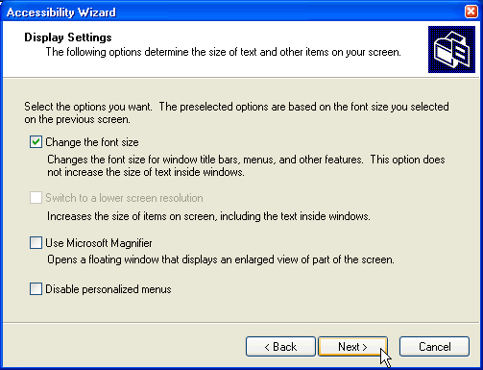

### The Set Wizard Options Page

On this page, select the type of disability that you have so the wizard can help you select some options to meet your needs. For example, if you choose, "I have difficulty using the keyboard or mouse," the next several pages present you with options to best meet your needs. Make your selection(s) and click Next.

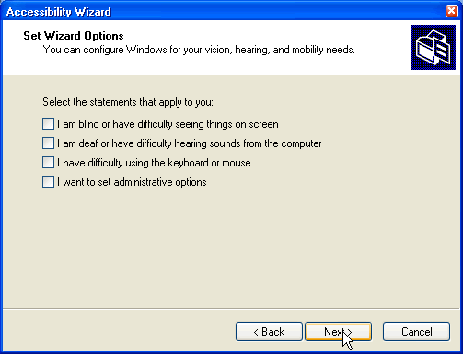

http://www.gcflearnfree.org/graphics/lessons/com_lesson_check.gifContinue using the Accessibility Wizard until you reach a summary screen. Windows XP is now configured for your needs.

**The Magnifier**

Remember, the **Accessibility Wizard**, working with your responses, enables such utilities as magnifier, narrator, on-screen keyboard, and utility manager. However, you can also turn them on via the Start menu.

**Microsoft Magnifier** makes the screen more readable. It creates a **separate window** that shows a magnified portion of your screen.

**To open the Magnifier using the Start menu:**

* Choose **Start**http://www.gcflearnfree.org/graphics/lessons/com_lesson_action.gif**All Programs**http://www.gcflearnfree.org/graphics/lessons/com_lesson_action.gif**Accessories**http://www.gcflearnfree.org/graphics/lessons/com_lesson_action.gif**Accessibility**http://www.gcflearnfree.org/graphics/lessons/com_lesson_action.gif**Magnifier**.

Whether you open the Magnifier using the Accessibility Wizard or using the Start menu, the **Magnifier Settings** window opens.

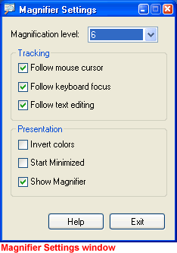

**Here, you can:**

* **Set the magnification level.** The default setting is 2. Use the drop down arrow to select the size that meets your needs.
* **Follow the Mouse Cursor.** By default, the Magnifier shows whatever you are pointing to with your mouse.
* **Follow Keyboard Focus.** By default, the Magnifier follows what you do on the keyboard.
* **Follow Text Editing.** When typing a document, the Magifier follows the cursor and magnifies the text as you type or make changes.
* **Invert Colors.** Inverts the colors in the magnifier.
* **Start Minimized.** The Magnifier starts as a minimized option on your computer.
* **Show Magnifier.** By default, the Magnifier shows at the top of the screen.

**The Narrator**

The **Narrator** can read items on the screen to you. However, the Narrator works only in English and may not work with every program installed on your computer. Your computer will also need to be equipped with a sound card and speakers for the narrator to function properly.

**To open the Narrator using the Start menu:**

* Choose **Start**http://www.gcflearnfree.org/graphics/lessons/com_lesson_action.gif**All Programs**http://www.gcflearnfree.org/graphics/lessons/com_lesson_action.gif**Accessories**http://www.gcflearnfree.org/graphics/lessons/com_lesson_action.gif**Accessibility**http://www.gcflearnfree.org/graphics/lessons/com_lesson_action.gif**Narrator**.

Whether you open the Narrator using the Accessibility Wizard or using the Start menu, the **Narrator** window opens.

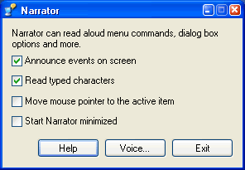

**Here, you can:**

* **Announce events on screen.** Narrator announces new windows that appear or system messages.
* **Read typed characters.** Narrator reads typed characters aloud.
* **Move mouse pointer to the active item.** Narrator moves your mouse pointer to the active window item for you.
* **Start Narrator minimized.** Narrator starts as a minimized option.

**The Onscreen Keyboard and Utilities Manager**

The **Onscreen Keyboard** opens an onscreen keyboard on your screen. You can use the mouse to click the keys. This is a limited version, but you can learn about other utilities such as this at <http://www.microsoft.com/enable>.

The **Utilities Manager** is a helpful tool that allows you to manage all of the Accessibility tools.

**To start the Utilities Manager:**

* Hold down the **Windows key + U**.

OR

* Choose **Start**http://www.gcflearnfree.org/graphics/lessons/com_lesson_action.gif**All Programs**http://www.gcflearnfree.org/graphics/lessons/com_lesson_action.gif**Accessories**http://www.gcflearnfree.org/graphics/lessons/com_lesson_action.gif**Accessibility**http://www.gcflearnfree.org/graphics/lessons/com_lesson_action.gif**Utilities Manager**.
* The **Utilities Manager** opens.

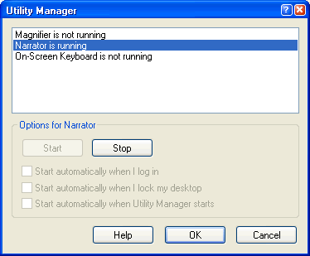

http://www.gcflearnfree.org/graphics/lessons/com_lesson_check.gifThis window tells you which Accessibility tools are currently running and may help you troubleshoot any problems.

**Opening the Help and Support Center**

You don't have to remember how to do everything with Windows XP. If you get stumped, Windows XP features an easy-to-use **Help and Support Center** to assist you.

**To access the Help and Support Center:**

* Click **Start**http://www.gcflearnfree.org/graphics/lessons/com_lesson_action.gif**Help and Support**.
* The **Help and Support Center** window opens.
* The home section is displayed.

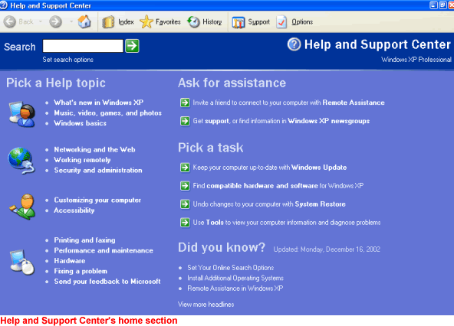

http://www.gcflearnfree.org/graphics/lessons/com_lesson_check.gifWhen you first on the Help and Support Center, you arrive in the home section. Here, you can pick a help topic, pick a task, search, and ask for outside assistance. Notice that the Home section looks and acts much like a web page. As you use Help, notice that some Help files are stored on your computer, whereas others are stored on the Internet.

**The Index**

Notice the buttons across the top of the home section. The **Index option** works like any other index, providing you with a fast and easy way to locate topics and resources.

**To use the Index:**

* Open the **Help and Support Center**.
* Click the **Index** button. Index button
* The **Index** opens. The entire index is displayed in alphabetical order in the **left pane**.
* Type in a keyword that pertains to the topic you're interested in.
* Double-click a topic you want to explore in the left pane. Information about the topic displays in the right pane or a **Topics Found** dialog box appears.
* If a **Topics Found** dialog box appears, click **Display** or **Cancel**
* If you click **Display**, information about the topic displays in the right pane.
* Click **Cancel** to close the dialog box and begin a new search.

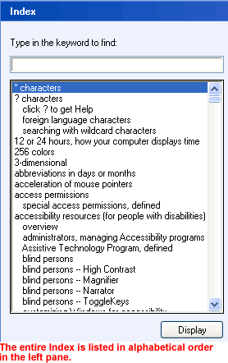

### Favorites and History

http://www.gcflearnfree.org/graphics/lessons/com_lesson_arrow.gif**Favorites**  
The **Favorites** option works much like Favorites in Internet Explorer. Whenever you find a help page you want to visit again in the future, click the **Add to Favorites** button. The page will be added to a Favorites list.

Add to Favorites button

When you want to review your **Help Favorites**, open the **Help and Support Center** and click the **Favorites** button.

Favorites button

http://www.gcflearnfree.org/graphics/lessons/com_lesson_arrow.gif**History**  
The **History option**, as in Internet Explorer, keeps track of all of the Help and Support Center pages you have visited on the Internet. To review pages you've visited in the past, click the **History** button. Double-click any of the links to display any of the pages.

### Support

If you are having trouble with Windows XP that you can't resolve on your own, there is support available to you in the Help and Support Center. To access **Support**, click the **Support** button.

Support button

##### You can get support in a variety of ways:

http://www.gcflearnfree.org/graphics/lessons/com_lesson_arrow.gif**Ask a friend to help.** If you have an Internet connection, you can invite someone you trust to chat with you, view your desktop, and work on your computer.

http://www.gcflearnfree.org/graphics/lessons/com_lesson_arrow.gif**Get help from Microsoft.** Using an Internet connection, you can allow a Microsoft support professional to answer your questions via email, chat, view your screen, or work on your computer.

http://www.gcflearnfree.org/graphics/lessons/com_lesson_arrow.gif**Go to a Windows Web site forum.** Windows Newsgroups are online resources that allow to you to communicate with other Windows users about any problems you may be having.

**Help's Search Function**

**Searching** for help topics is perhaps the fastest and most useful way to use the **Help and Support Center**.

**To use search:**

* Open the **Help and Support Center**.
* In the **Search box**, type in a keyword that pertains to the topic you're interested in and click the green arrow key.



* Your search results are listed in the **left pane**.

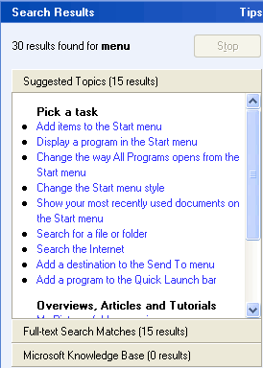

* Click to choose a result that best answers your concerns.
* The explanation will display in the **right pane**.

**The Printers and Faxes Folder**

Windows XP stores any information about any printer or fax machines connected to your computer in a **Printers and Faxes folder**, making it easy to install, manage, and use printers and fax machines.

**To view the Printers and Faxes folder:**

* Open the **Control Panel**.
* Under Pick a Category, choose **Printers and Other Hardware**.
* The **Printers and Other Hardware** folder opens.
* Under Pick A Task, choose **View installed printer or fax printers** or **Add a printer**.
* The **Printers and Faxes** folder opens.
* In the **left** pane, you'll see several helpful links.
* In the **right** pane, you see a list of any printers or faxes that are installed on your machine.

**Adding a Printer**

Adding a printer is simple using the **Add Printer Wizard** available in the Printers and Faxes folder.

**Before trying to add a printer:**

* Make sure your printer is compatible with Windows XP. If buying a new printer, make sure to do your research before you make a purchase.
* Get out your printer's manual or CD-ROM and read it.
* Set up your printer and attach it to your computer using a printer's cable and correct port on your computer.

http://www.gcflearnfree.org/graphics/lessons/com_lesson_check.gif**Note:** Many of the latest Plug and Play printers connect through a USB port. If your printer falls into this category, you may not need the Add a Printer Wizard. If you do have to use the wizard and your printer isn't listed in the Windows XP list (which usually displays when you try to add a new printer) you may have to contact the printer manufacturer for a driver. When you get the driver, follow the Add a Printer instructions on your computer.

**Having Trouble Printing It?**

Perhaps you've written a great report and you want to share it with your boss. The problem is, you're having trouble printing it.

**Try these troubleshooting techniques:**

* Take care of the basics. Make sure the printer is **plugged in, turned on and has paper** in it.
* Make sure the **printer cable** is properly connected to the printer and to the computer.
* Check to see if there is a **paper jam**. Most printers have a flashing light to indicate a jam. Also, if the paper size selected differs from the one in the paper tray, you will not be able to print. To choose a paper size, select **File**http://www.gcflearnfree.org/graphics/lessons/com_lesson_action.gif**Page Setup**. Click the **Paper Size** tab.
* Check to see that the printer **toner, cartridge or ribbon** is fresh and adequate. If not, printed documents may appear streaky, blotchy, or even blank.
* Make sure the printer switched to **Online mode**. There is usually a button on your printer's control panel. If it is switched to Offline mode, it will not print.
* Make sure the computer knows what printer you are using. Check this by clicking **Start**http://www.gcflearnfree.org/graphics/lessons/com_lesson_action.gif**Control Panel**http://www.gcflearnfree.org/graphics/lessons/com_lesson_action.gif**Printers and Other Hardware**http://www.gcflearnfree.org/graphics/lessons/com_lesson_action.gif**View installed printers or fax printers**. If an icon for your printer doesn't appear, try restarting your computer. If you printer still doesn't appear, you may need to add it. Click Add a Printer and follow the instructions in the Add Printer Wizard.

**More Printer Troubleshooting Tips**

Because so many issues can affect your printer, you should also consider these problem-solving tips:

* If you work in an office environment where several people share a printer, there may be a **network** problem. Contact your Network Support person.
* If you can find the **manual** for your printer, read it to see if you can find the solution to the problem.
* If your printer still doesn't work, go to **Help and Support Center**. Under Pick a Help Topic, click **Printing and Faxing**. Or, enter the term printer into the Search box.
* Open the **Printing Troubleshooter**. Answer the questions and follow the instructions so the computer can help you figure out what's wrong.

**To open the Printing Troubleshooter:**

* Click **Start**http://www.gcflearnfree.org/graphics/lessons/com_lesson_action.gif**Control Panel**http://www.gcflearnfree.org/graphics/lessons/com_lesson_action.gif**Printers and Other Hardware**.
* In the **left** pane, open the **Troubleshooters** category.
* Click **Printing**.
* The **Printing Troubleshooter** opens.

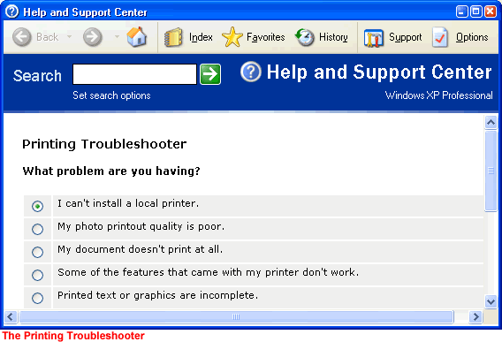

**What are Systems Tools?**

Do some basic maintenance from time to time to keep Windows XP running smoothly. Luckily, Windows XP provides you with some basic tools to make the maintenance process as painless as possible. You can access these tools via the **System Tools menu**.

**To open the System Tools menu:**

* Choose **Start** http://www.gcflearnfree.org/graphics/lessons/com_lesson_action.gif**All Programs**http://www.gcflearnfree.org/graphics/lessons/com_lesson_action.gif**Accessories**http://www.gcflearnfree.org/graphics/lessons/com_lesson_action.gif**System Tools**.
* A cascading **System Tools** menu opens.

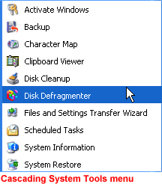

**Disk Defragmenter**

All Windows XP computers have at least one **hard disk**. The hard disk acts as your computer's storage area. Almost everything installed on your computer - applications, files, folders, and operating system - is stored here.

With general use, (creating new files, deleting files, installing new software, etc) your hard disk can become **fragmented**. This means that parts of the same disk file become scattered over different areas of the disk. A fragmented hard disk slows down your computer and hinders its performance.

To keep your hard disk running smoothly, you must routinely **defragment or "defrag"** the hard disk. The **Disk Defragmenter** tool can help you do this.

**To use Disk Defragmenter:**

* Choose **Start**http://www.gcflearnfree.org/graphics/lessons/com_lesson_action.gif**All Programs**http://www.gcflearnfree.org/graphics/lessons/com_lesson_action.gif**Accessories**http://www.gcflearnfree.org/graphics/lessons/com_lesson_action.gif**System Tools**http://www.gcflearnfree.org/graphics/lessons/com_lesson_action.gif**Disk Defragmenter**.
* The **Disk Defragmenter** opens.

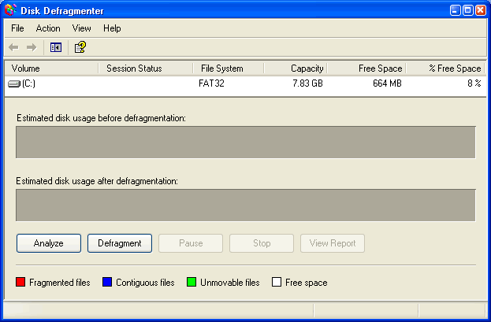

**To open Microsoft Management Console:**

* Open **Disk Defragmenter**.
* Open the **Action** menu.
* Click **Help**.
* A **Microsoft Management Console** opens and explains how to run **Disk Defragmenter**.

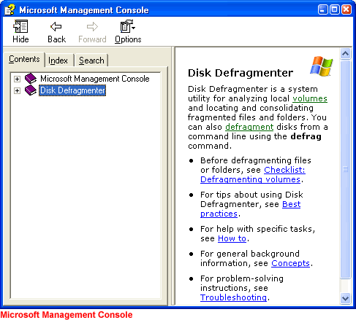

http://www.gcflearnfree.org/graphics/lessons/com_lesson_check.gif**Note:** You may need to be logged in as an administrator or as a member of the Administrators group to perform some tasks associated with the Disk Defragmenter. Disk Defragmenter should be run every three months.

**Disk Cleanup**

**Disk Cleanup** is another tool that helps keep Windows XP operating as it should. It inspects your hard disk and looks for files that can be safely deleted. Deleting unnecessary files frees up valuable disk space.

**To run Disk Cleanup:**

* Choose **Start**http://www.gcflearnfree.org/graphics/lessons/com_lesson_action.gif**All Programs**http://www.gcflearnfree.org/graphics/lessons/com_lesson_action.gif**Accessories**http://www.gcflearnfree.org/graphics/lessons/com_lesson_action.gif**System Tools**http://www.gcflearnfree.org/graphics/lessons/com_lesson_action.gif**Disk Cleanup**.
* The **Disk Cleanup** window opens. Click the Disk Cleanup tab if it's not showing.
* Disk Cleanup lists several potential files that can be deleted and the amount of disk space you'll gain by emptying each one.
* To learn more about a file category, click it and click the **View Files** button. A description appears.
* Click the **checkboxes** next to the categories you want to **delete** and click OK.
* A dialog box appears, stating, **"Are you are sure you want to perform these actions?"** Click Yes or No as appropriate.

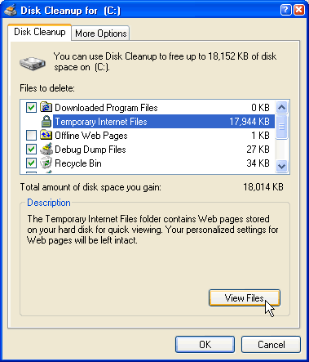

### Disk Cleanup (Continued)

The **More Options tab** gives you even more disk cleanup options.

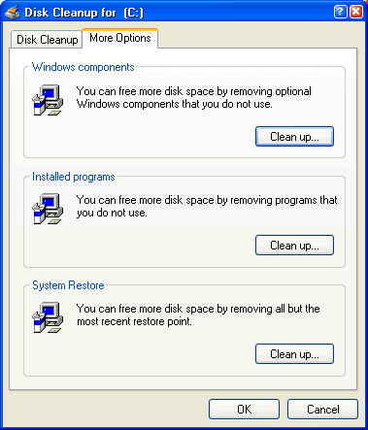

http://www.gcflearnfree.org/graphics/lessons/com_lesson_check.gif**Note:** It's recommended that you run Disk Cleanup every three months.

**The Scheduled Task Wizard**

Fortunately, you don't need to remember to run each of these utilities. Windows XP includes a Scheduled Task Wizard that runs each of them for you.

**To open the Scheduled Task Wizard:**

* Choose **Start**http://www.gcflearnfree.org/graphics/lessons/com_lesson_action.gif**All Programs**http://www.gcflearnfree.org/graphics/lessons/com_lesson_action.gif**Accessories**http://www.gcflearnfree.org/graphics/lessons/com_lesson_action.gif**System Tools**http://www.gcflearnfree.org/graphics/lessons/com_lesson_action.gif**Scheduled Tasks**.

OR

* Choose **Start**http://www.gcflearnfree.org/graphics/lessons/com_lesson_action.gif**Control Panel**http://www.gcflearnfree.org/graphics/lessons/com_lesson_action.gif**Performance and Maintenance**http://www.gcflearnfree.org/graphics/lessons/com_lesson_action.gif**Scheduled Tasks**.

THEN

* The **Scheduled Tasks** folder opens.
* Double-click **Add a Scheduled Task**.
* The **Scheduled Tasks Wizard** opens.
* Keep clicking **Next** to select the program(s) you want Windows to run. If the task you want is not listed, click the **Browse** button to locate it. Then schedule a convenient time.

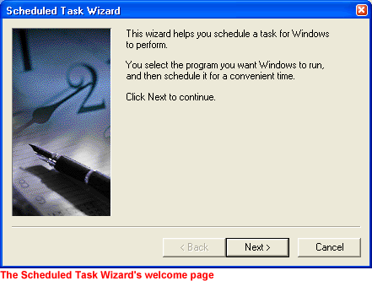

**Dealing with an Unresponsive Computer**

While doing regular maintenance on your computer should keep it running smoothly, your computer may occasionally freeze up or become unresponsive to the click of a mouse or keyboard.

* If your computer freezes, **try waiting it out**. Sometimes it takes your computer a few seconds to complete a task.

OR

* Press the **ESC** on your keyboard.

OR

* Press **Ctrl + Alt + Delete** on your keyboard. The **Windows Task Manager** opens. Here, monitor applications, processes, performance, networking, and users. If you need to restart your computer, choose **Shut Down**http://www.gcflearnfree.org/graphics/lessons/com_lesson_action.gif**Restart**. If you need to turn off your computer, choose **Shut Down**http://www.gcflearnfree.org/graphics/lessons/com_lesson_action.gif**Turn Off**.

